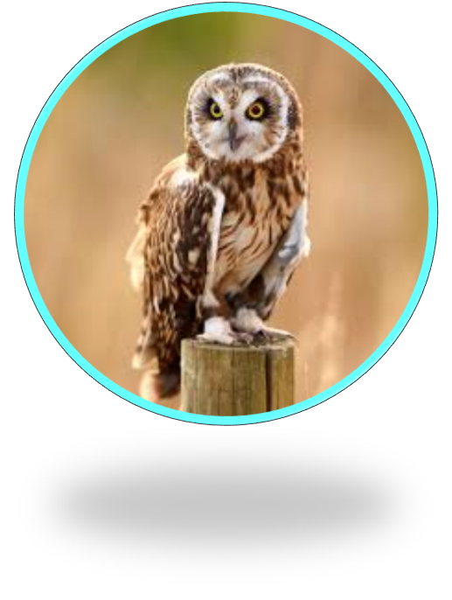



Emotionally intelligent
work as a team
listen
manage your feelings
Creative
imagine
solve problems
be unique

Resilient
challenge yourself
be brave
concentrate
Independent
ask questions
explore
look closer

