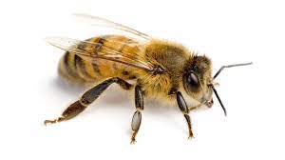

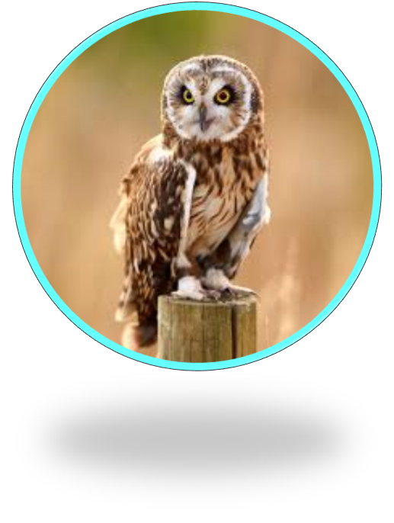

Creative
be versatile
be innovative
use a different perspective

Resilient
be persistent
be determined
be positive
Emotionally intelligent
self – regulate
reason
be perceptive
Independent
research
evaluate
analyse

