We believe 'art, craft and design embody some of the highest forms of human creativity. A high-quality art and design education should engage, inspire and challenge pupils, equipping them with the knowledge and skills to experiment, invent and create their own works of art, craft and design. Our art and design curriculum ensures a breadth of experience, knowledge and skills. It is linked to the national curriculum, and develops clear progression of skills and concepts by building upon and revisiting important processes. Our aim is to enable personal expression, to develop emotional well-being and to foster a life-long relationship with creativity.
At Bosham Primary School, pupil’s knowledge, understanding and skills are developed through looking at, discussing and creating art, craft and design through a wide range of exciting learning experiences. Pupils will be introduced to a wide range of creative practitioners in art, craft and design from different times, cultures, and societies. These creative practitioners are a source of inspiration for children and will help them to understand how art and design both reflect and contribute to our culture.
Our art and design curriculum sequences how our pupils can ‘get better’ in art and design as they progress through the school. Pupils make progress in the art when they learn how to connect practical knowledge, theoretical knowledge and disciplinary knowledge.
Our Learning experiences will give pupils opportunities to:
- develop the practical knowledge of how to create pieces of work by learning the methods and techniques that artists, craft-makers and designers use.
- build theoretical knowledge of the tools, materials and history of art, craft and design.
- acquire disciplinary knowledge of the concept of art itself, such as the ways it is judged, valued and evaluated.
Sketch books records a pupil’s thinking process and allows them to review and revisit ideas. They provide a space for recording their ideas and inspirations and a place to practice and refine their skills.
We plan for pupils to develop practical, foundational and theoretical knowledge in:
- Drawing
- Painting
- Printing
- Collage
- Sculpting

We will ensure that all pupils:
- produce creative work, exploring their ideas and recording their experiences.
- become proficient in drawing, painting, sculpture and other art, craft and design techniques.
- evaluate and analyse creative works using the language of art, craft and design.
- know about great artists, craft makers and designers, and understand the historical and cultural development of their art forms.

 | Autumn |  |  | Spring |  | Summer
EYFS | Area of EYFS:  Expressive arts and design
EYFS | Key skills and knowledge:  To mix colours  To use simple tools and materials  To talk about what we create
EYFS | Drawing | Control a variety of drawing media in order to use lines to create shapes, patterns and textures on a range of surfaces.
EYFS | Painting | Name and use primary colours, black and white, to make and repeat various marks and lines. Hold and start to develop control over a variety of media and paint from observation or experience.
EYFS | Printing | Experience various types of printing. They should be taught to experiment with a range of methods and word on a range of surfaces and scales.
EYFS | Collage | Use scissors to cut a range of materials in straight lines. Tear paper and apply adhesive sparingly to glue surfaces together accurately.
EYFS | Sculpture
EYFS | Opportunities across the year:  Creative areas in class- painting and making table  Role play – prop making
EYFS | Jackson Pollock  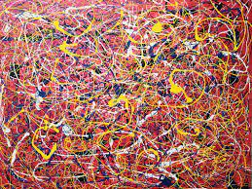 |  | 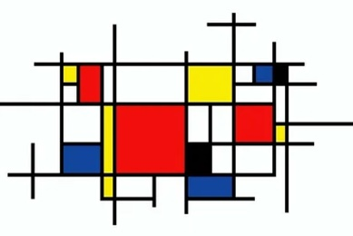  Piet Mondrian | 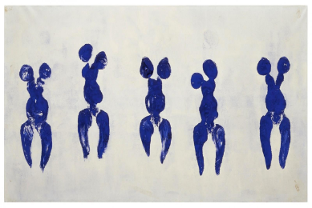  Yves Klein | 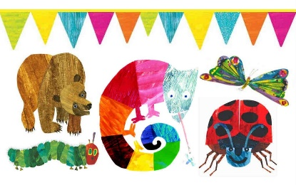  Eric Carle | Van Gogh  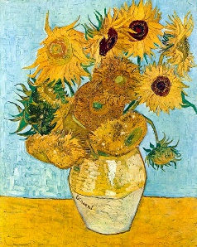 | Henri Matisse  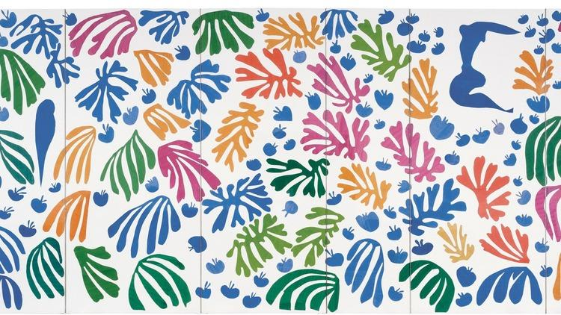
Milestones for Y1 & Y2 | Develop ideas: This concept involves understanding how ideas develop through an artistic process  • Respond to ideas and starting points.  • Explore ideas and collect visual information.  • Explore different methods and materials as ideas develop
Milestones for Y1 & Y2 | Master techniques: This concept involves developing a skill set so that ideas may be communicated
Milestones for Y1 & Y2 | Drawing | Develop control of an increasing variety of media. Drawings show increasing detail, context and se of the visual elements. Draw from observation, experience and for a range of purposes.
Milestones for Y1 & Y2 | Painting | Name primary and secondary colours and begin to qualify their tonal value. Mis and match colours. Develop control over the medium and colour in accurately.
Milestones for Y1 & Y2 | Printing | Load a range of different objects with paint to print. Make simple polystyrene printing locks. Mono prints are made. Experiment with printing techniques.
Milestones for Y1 & Y2 | Collage | Cut straight and curved lines from a range of materials with some accuracy. Tear paper and apply adhesive sparingly to a range of materials and stick them down accurately. Classify materials into colours and surface textures and make their own simple collages.
Milestones for Y1 & Y2 | Sculpture
Milestones for Y1 & Y2 | Take inspiration from the greats: Van Gogh, Bridget Riley, William Morris.
Year 1 |  |  | Remember, Remember LE – Painting Fireworks  • Use thick and thin brushes  • Mix primary colours to make secondary  • Add white to colours to make tints and black to colours to make tones  • Create colour wheels  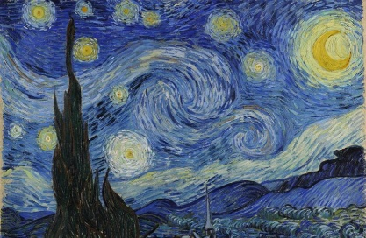  Inspired by Van Gogh | Op Art (Drawing)  - Draw lines of different sizes and thickness  - Bridget Riley Artist  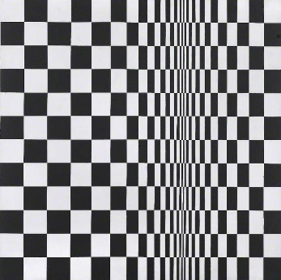 |  | Powerful Plants LE - Nature Prints (Print) in the style of William Morris  - Draw a flower including the parts covered in science.  - Draw lines of different sizes and thickness.  - Colour (own work) neatly following the lines.  - Show pattern and texture by adding dots and lines.  - Show different tones by using coloured pencils.  - Use repeating or overlapping shapes.  - Mimic print from the environment (e.g. wallpapers).  - Use objects to create prints (e.g. fruit, vegetables or sponges).  - Press, roll, rub and stamp to make prints.  - Pattern  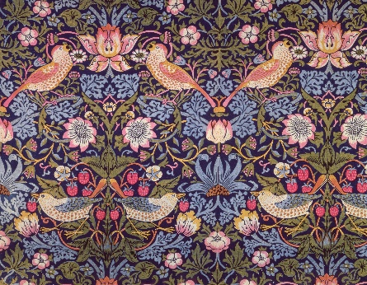 | Carnival of the Animals LE - Create an Animal  - Create an animal from any learnt animal group and create the key features of that group.  - Use a combination of materials that are cut, torn and glue.  - Sort and arrange materials  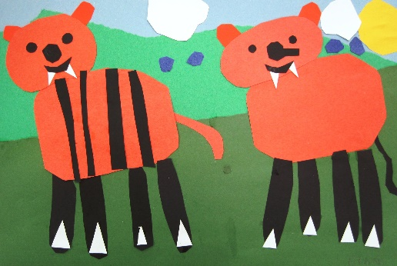
Year 2 | Here We Are LE - Self-Portraits  - Draw lines of different sizes and thickness  - Show pattern and texture by adding dots and lines  - Show different tones by using coloured pencils  - Frida Kahlo, Picasso and other self-portrait artists  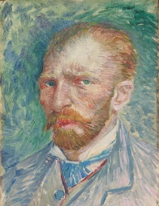  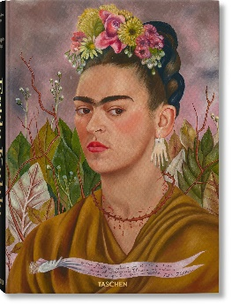  Drawing  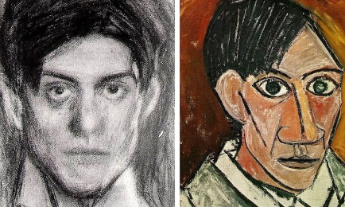 |  |  |  | The Secret Garden LE – Andy Warhol  - Use thick and thin brushes  - Add white to colours to make tints and black to colours to make tones  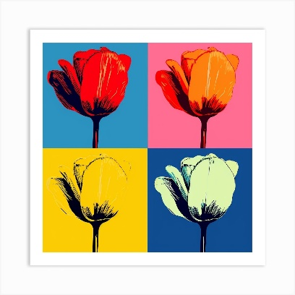  Painting |  | Wild & Wonderful LE - Create a Habitat (Collage)  • Use a combination of materials that are cut, torn and glued  • Sort and arrange materials  • Mix materials to create texture  Sculpture
Year 2 | Take inspiration from the greats = Frida Kahia, Picasso, Andy Warhol
Milestones for Y3 & Y4 | Develop ideas: This concept involves understanding how ideas develop through an artistic process  • Develop ideas from starting points throughout the curriculum.  • Collect information, sketches and resources.  • Adapt and refine ideas as they progress.  • Explore ideas in a variety of ways.  • Comment on artworks using visual language
Milestones for Y3 & Y4 | Drawing | Use specialist media to explore effects and identify visual elements in work. Produce detailed drawings and recognise the proportions of the human body. Adapt styles for different purposes.
Milestones for Y3 & Y4 | Painting | Begin to adapt and apply colours to achieve tonal effects. Work on a range of scales and surfaces appropriate to the work.
Milestones for Y3 & Y4 | Printing | Make more complex printing blocks using string, card etc. Ink up a block and print regular and offset patterns. Experiment with prints on fabric using inks.
Milestones for Y3 & Y4 | Collage | Cut complex shapes from a range of materials with some accuracy. Tear paper into predetermined shapes and change the surface of materials. Apply adhesive sparingly and stick shapes down accurately to produce own collages.
Milestones for Y3 & Y4 | Sculpture | Create and combine shapes to create recognisable forms (e.g. shapes made from nets or solid materials). Include texture that conveys feelings, expression or movement Use clay and other mouldable materials. Add materials to provide interesting detail.
Milestones for Y3 & Y4 | Take inspiration from the greats: Eileen Downes,
Year 3 | Where Your Wellies Take You LE - Collage  Select and arrange materials for a striking effect  - Ensure work is precise.  - Use coiling, overlapping, tessellation, mosaic and montage  Eileen Downes Artist  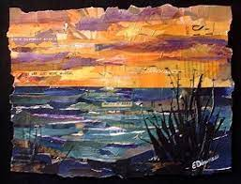  Painting  - Use watercolour paint to produce washes or backgrounds then add detail  - Experiment with creating mood with colour |  |  |  | Groovy Greeks LE – Greek Vase  - Create and combine shapes to create recognisable forms  - Include texture that conveys feelings, expression or movement  - Use clay or other mouldable materials  - Add materials to provide interesting detail.  Sculpture  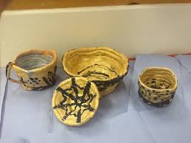 | Submit & Obey LE – Prayer Mats  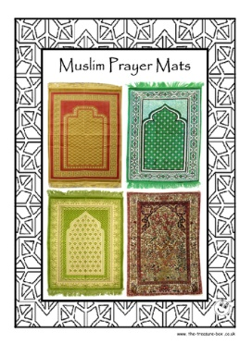  Use layers of two or more colours.  Replicate patterns observed in natural or built environments.  Make printing blocks (e.g. from coiled string glued to a block).  Make precise repeating patterns.  Print  Painting  - Use a number of brush techniques using thick and thin brushes to produce shapes and textures, patterns and lines  - Mix colours effectively | Back to the Future LE - Drawing  • Use different harnesses of pencils to show line, tone and texture.  • Annotate sketches to explain and elaborate ideas.  • Sketch lightly (no need to use a rubber to correct mistakes).  • Use shading to show light and shadow.  • Use hatching and cross hatching to show tone and texture.
Year 3 | Take inspiration from the greats =
Year 4 | Mosaics – Roman Mosaics (Collage & Digital Media)  - Use a combination of colours that are cut into different sizes to create an image  - Sort and arrange materials  - Mix materials to create texture  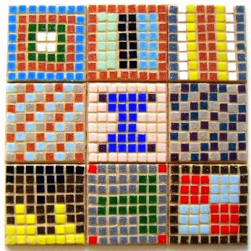  - Using digital media to create a mosaic pattern  - Select and arrange materials for a striking effect  - Ensure work is precise. |  | Clay Diva laps  - Use clay and other mouldable materials | Recycled materials (Sculpture)  Plastic island (reuse plastic – Great Pacific Garbage Patch)  • Create and combine shapes to create recognisable forms (e.g. shapes made from nets or solid materials).  • Include texture that conveys feelings, expression or movement  • Add materials to provide interesting detail. | Food Chain Artwork (Collage)  Create cartoon animal food chains where each part of the chain is inside the animal that consumes it.  • Select & arrange materials for a striking effect  • Ensure work is precise.  • Use overlapping and montage |  | Maya Wall Mural (Painting)  - Use a number of brush techniques using thick and thin brushes to produce shapes, textures, patterns and lines  - Mix colours effectively  - Experiment with creating mood with colour  - Use acrylic paint in the style of Maya art
Year 4 | Take inspiration from the greats = David Hockney (UK artist who creates colourful landscape paintings)
Milestones for Y5 & Y6 | Develop ideas: This concept involves understanding how ideas develop through an artistic process  • Develop and imaginatively extend ideas from starting points throughout the curriculum.  • Collect information, sketches and resources and present ideas imaginatively in a sketch book.  • Use the qualities of materials to enhance ideas.  • Spot the potential in unexpected results as work progresses.  • Comment on artworks with a fluent grasp of visual language
Milestones for Y5 & Y6 | Drawing | Plan the effective use of drawing spaces and develop techniques that enable them to create key elements, including proportion and simple perspective. Select media and style suited to the purpose.
Milestones for Y5 & Y6 | Painting | Work with a range of specialist media to achieve desired effects. Mix a full range of hues and tones and plan the effective use of available space. Include simple proportion and perspective in work.
Milestones for Y5 & Y6 | Printing | Apply more than one colour using pre-cut printing tiles. Investigate tessellated approaches with off-set prints on different surfaces. Understand commercial printing.
Milestones for Y5 & Y6 | Collage | Accurately cut complex shapes from a range of materials. Alter and amend a range of surfaces to create new textures, and plan and produce their own collages.
Milestones for Y5 & Y6 | Sculpture | Show life-like qualities and real-life proportions or, if more abstract, provoke different interpretations. Use tools to carve and add shapes, texture and pattern. Combine visual and tactile qualities. Use frameworks (such as wire or moulds) to provide stability and form
Milestones for Y5 & Y6 | Take inspiration from the greats:
Year 5 | Pathways: (Collage)  - Mix textures (rough and smooth, plain and patterned)  - Combine visual and tactile qualities  - Use ceramic mosaic materials and techniques |  | Fantastic Beast: (Drawing)  To draw their own Fantastic Beast  • Use a variety of techniques to add interesting effects (e.g. reflections, shadows, direction of sunlight).  • Use a choice of techniques to depict movement, perspective, shadows and reflection.  • Choose a style of drawing suitable for the work (e.g. realistic or impressionistic).  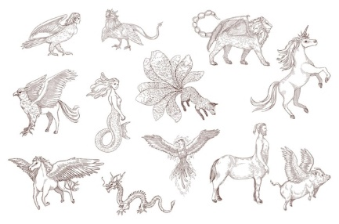  • Use lines to represent movement. |  | Dragon’s Eye (Sculpture)  Create a dragon’s eye using clay  - Show life-like qualities and real-life proportions or, if more abstract, provoke different interpretations  - Use tools to carve and add shapes, texture and pattern  - Combine visual and tactile qualities  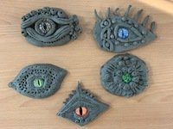  - Use frameworks (such as wire or moulds) to provide stability and form |  | Martin Impskey (Ink)  • Sketch (lightly) before painting to combine line and colour  • Create a colour palette based upon colours observed in the natural or built world  • Use the qualities of watercolour and acrylic paints to create visually interesting pieces  • Combine colours, tones and tints to enhance the mood of a piece  • Use brush techniques and the qualities of paint to create texture
Year 5 | Take inspiration from the greats = J. M. W. Turner (Coastal artist)  • Describe the work of notable artists, artisans and designers  • Use some of the ideas of artists studied to create pieces
Year 6 | 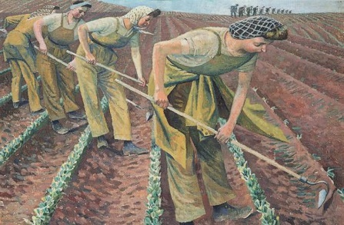  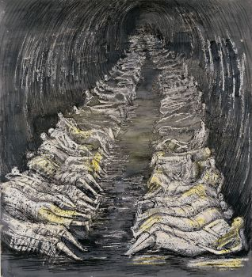  Fight or Flight LE - Henry Moore & Evelyn Dunbar |  |  | Mountain Collage Artwork – Henri Matisse (Digital Artwork)  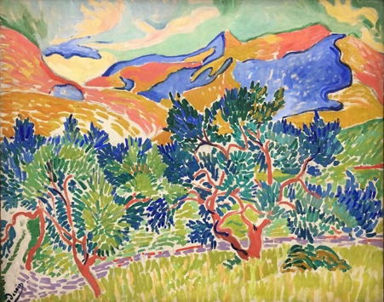  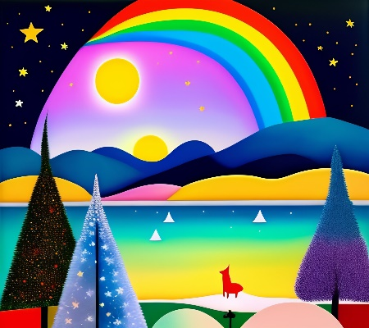 | Darwin’s Discoveries LE – Chicken Wire Artwork  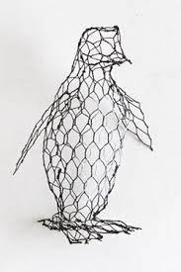  New species created in wire.
Year 6 | Take inspiration from the greats = Henry Moore & Evelyn Dunbar

