

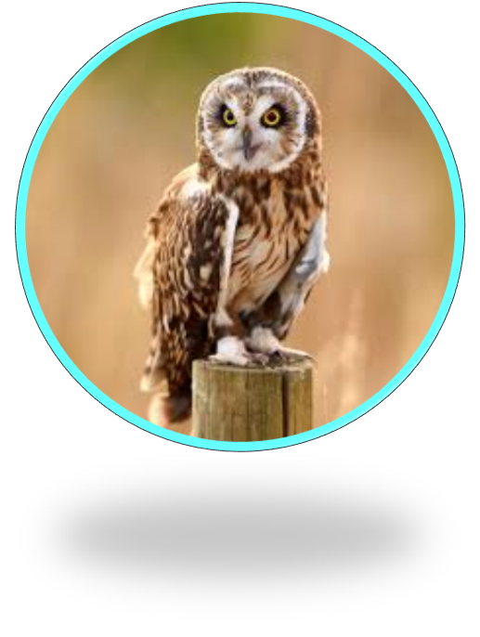

Creative
be versatile
be innovative
use a different perspective

Resilient
show persistence
be determined
have a positive mindset
Emotionally intelligent
self – regulate
reason
be perceptive
Independent
research
evaluate
analyse

