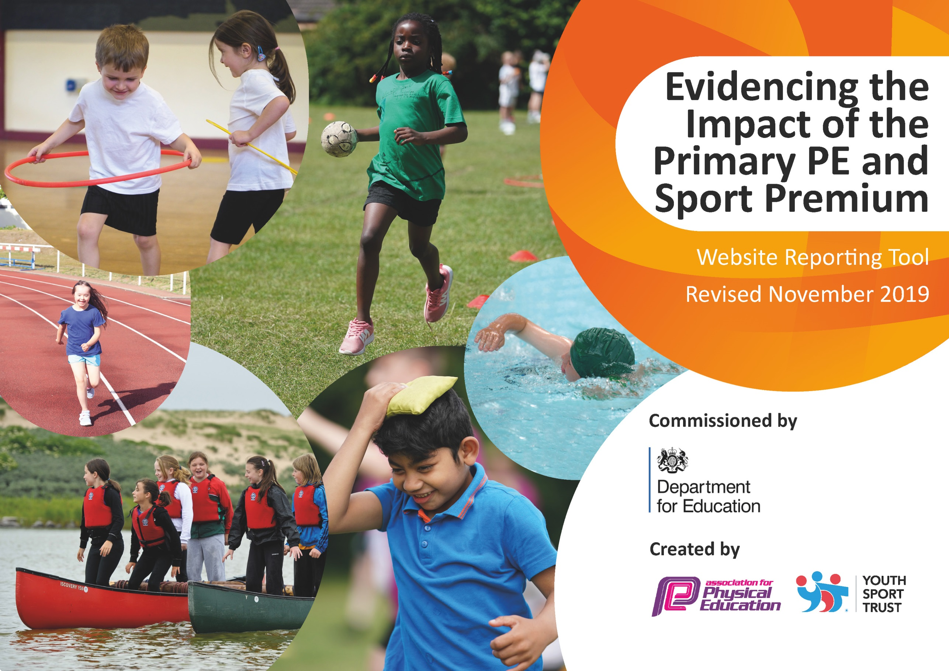
Written by Polly Neville – July 2020 to be revised September 2020
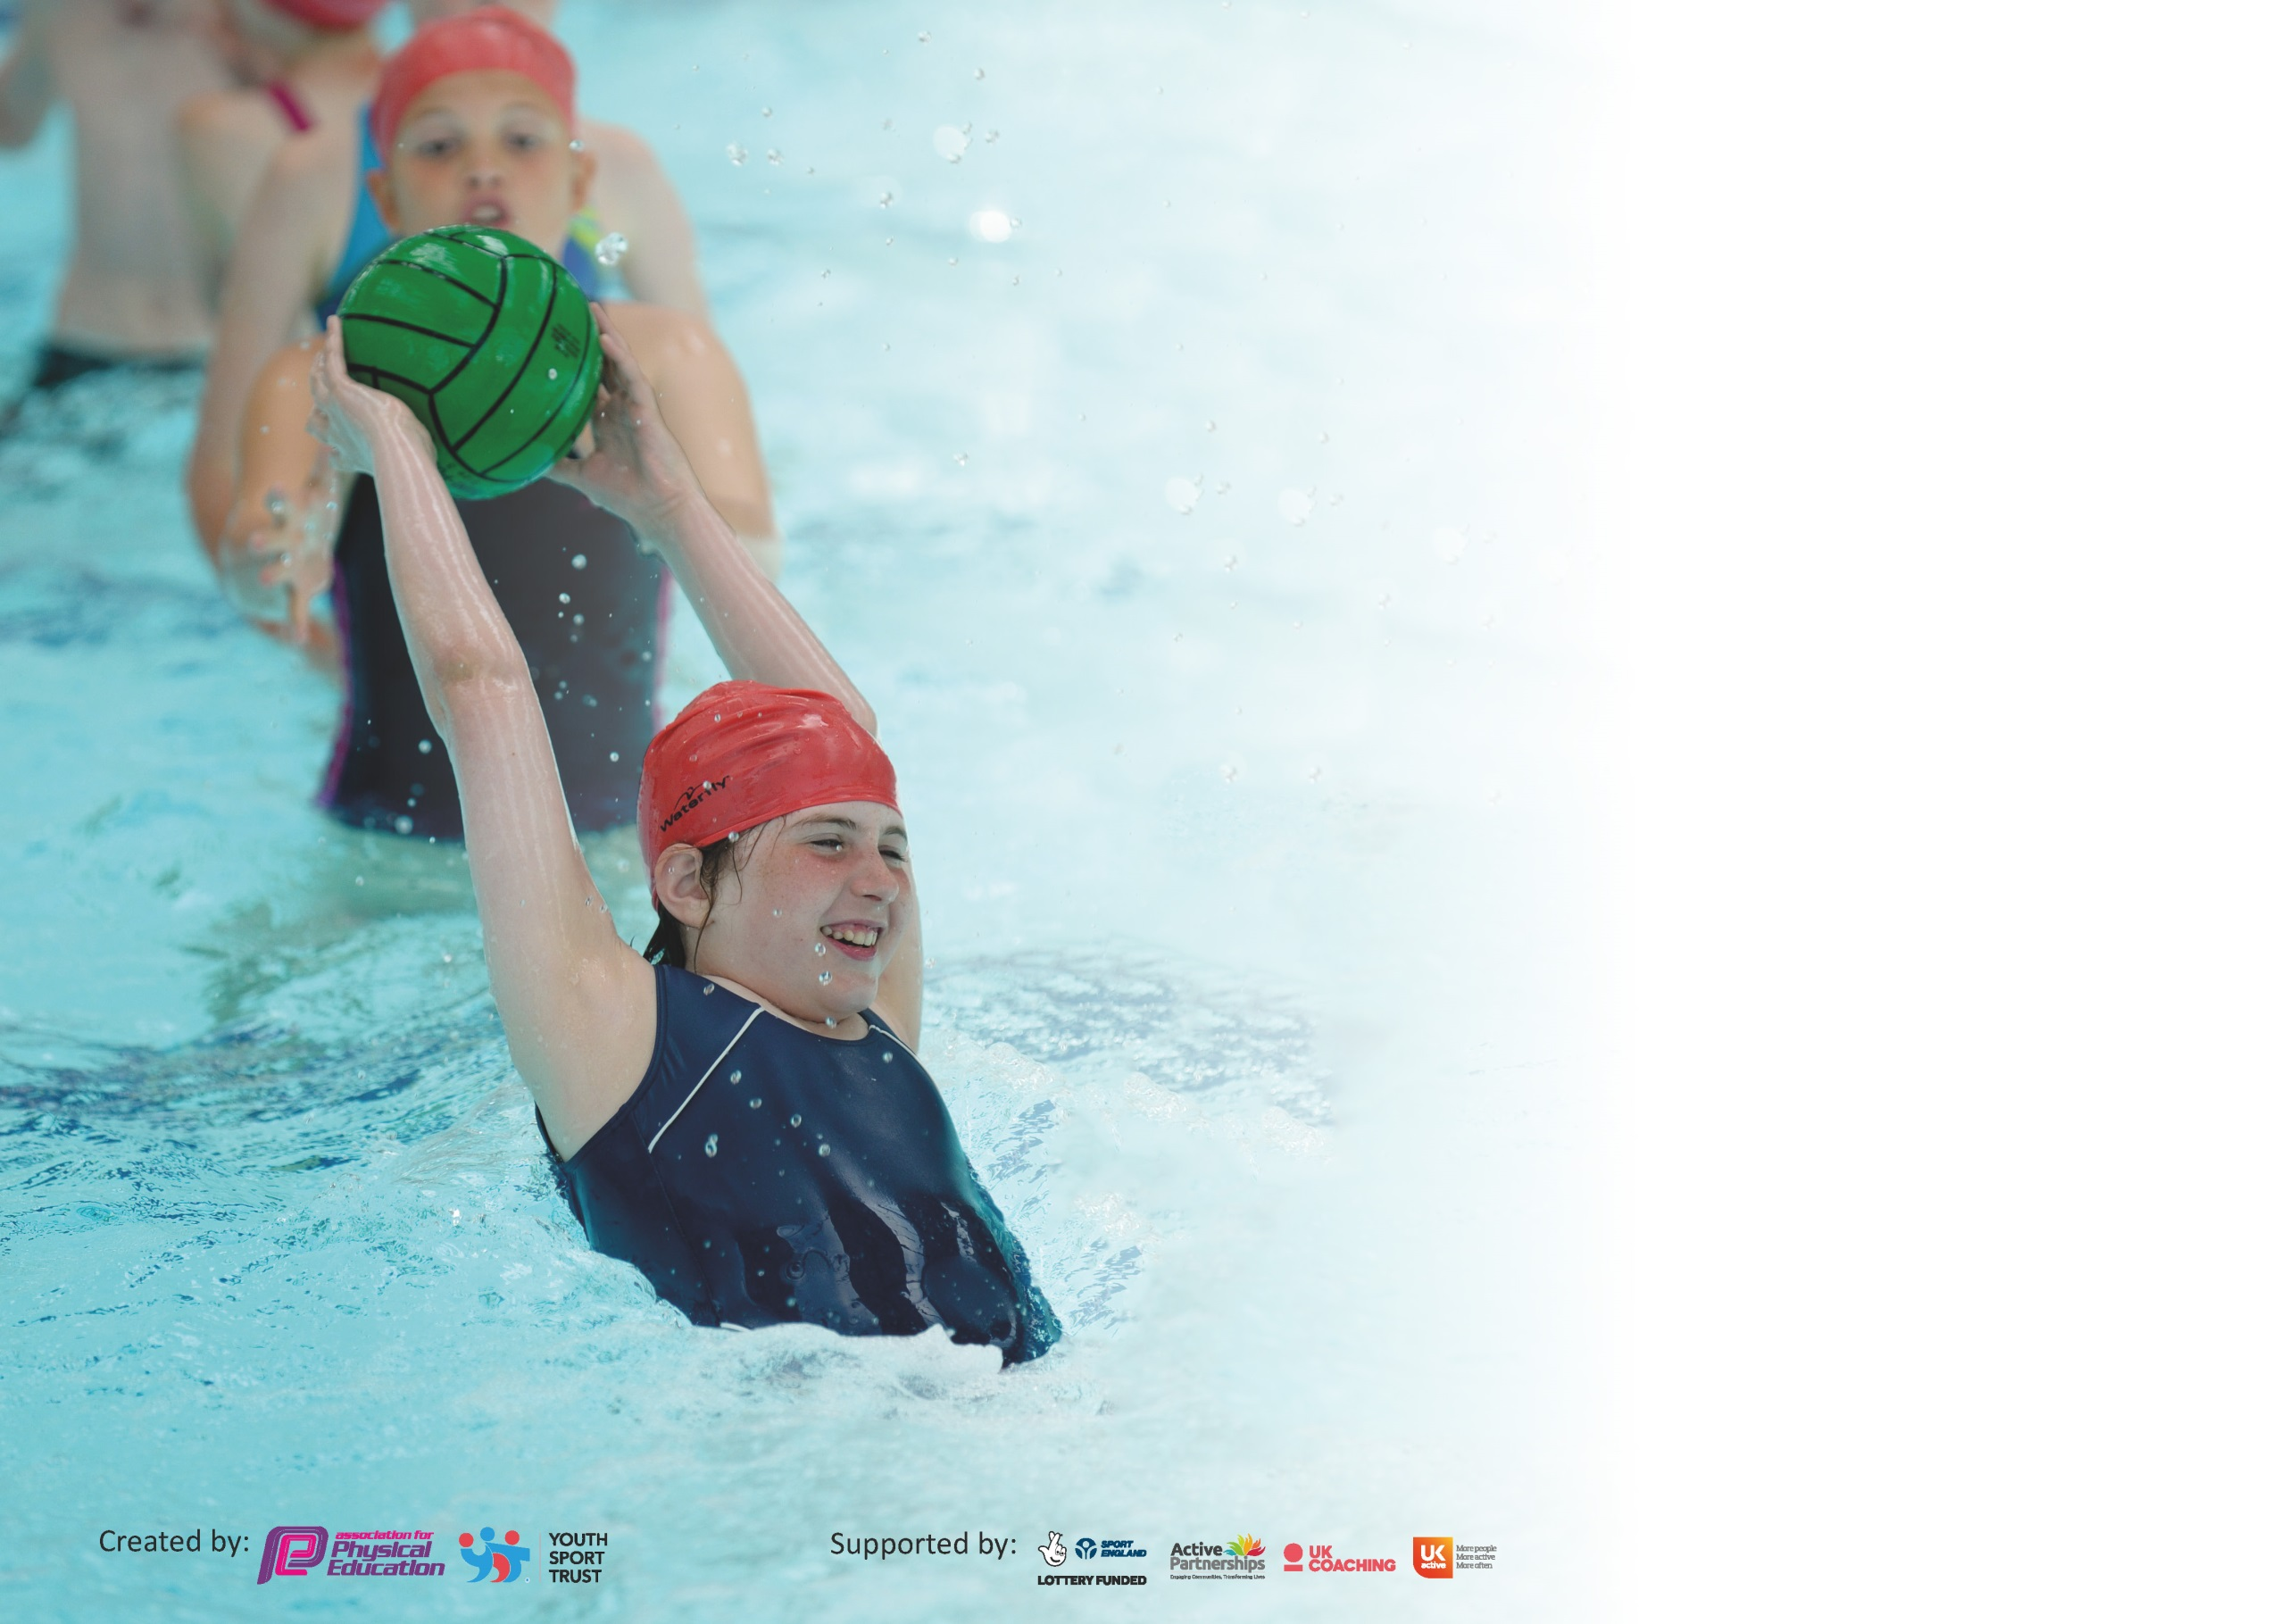

It is important that your grant is used effectively and based on school need. The Education Inspection Framework (Ofsted 2019 p64) makes clear there will be a focus on ‘whether leaders and those responsible for governors all understand their respective roles and perform these in a way that enhances the effectiveness of the school’.

Under the Quality of Education criteria (p41) inspectors consider the extent to which schools can articulate their curriculum (INTENT), construct their curriculum (IMPLEMENTATION) and demonstrate the outcomes which result (IMPACT).

To assist schools with common transferable language this template has been developed to utilise the same three headings which should make your plans easily transferable between working documents.

Schools must use the funding to make additional and sustainable improvements to the quality of Physical Education, School Sport and Physical Activity (PESSPA) they offer. This means that you should
use the Primary PE and Sport Premium to:

- Develop or add to the PESSPA activities that your school already offer
- Build capacity and capability within the school to ensure that improvements made now will benefit pupils joining the school in future years

Please visit gov.uk for the revised DfE guidance including the 5 key indicators across which schools should demonstrate an improvement. This document will help you to review your provision and to report your spend. DfE encourages schools to use this template as an effective way of meeting the reporting requirements of the Primary PE and Sport Premium.

We recommend you start by reflecting on the impact of current provision and reviewing the previous spend.

Schools are required to publish details of how they spend this funding as well as on the impact it has on pupils’ PE and sport participation and attainment by the end of the summer term or by 31st July 2020 at the latest.

We recommend regularly updating the table and publishing it on your website throughout the year. This evidences your ongoing self-evaluation of how you are using the funding to secure maximum, sustainable impact. Final copy must be posted on your website by the end of the academic year and no later than the 31st July 2020. To see an example of how to complete the table please click HERE.

Support for review and reflection - considering the 5 key indicators from DfE, what development needs are a priority for your setting and your pupils now and why? Use the space below to reflect on previous spend and key achievements and areas for development.

Key achievements to date until July 2020: | Areas for further improvement and baseline evidence of need:
- Excellent links established with local schools for interschool competitions – free. We were strongly on track to achieve Gold Games Mark before the school closures.  - 100% of staff feel supported if they need help with PE planning or teaching and are on board with using Real PE in future. 75% think their PE teaching has improved over the last 2 years due to the premium.  - 75% of families believe our PE provision at BPS encourages and supports their child to be active at home. 94% of children enjoy their PE lessons. | From staff and parent surveys:  - Supporting families to keep their children active at home  - Establishing Real PE teaching across the school  - Supporting all children and staff post Covid 19.

Meeting national curriculum requirements for swimming and water safety.
What percentage of your current Year 6 cohort swim competently, confidently and proficiently over a distance of at least 25 metres?  N.B. Even though your pupils may swim in another year please report on their attainment on leaving  primary school at the end of the summer term 2020. | 100%
What percentage of your current Year 6 cohort use a range of strokes effectively [for example, front crawl, backstroke and breaststroke]? | 100%
What percentage of your current Year 6 cohort perform safe self-rescue in different water-based situations? | 100%
Schools can choose to use the Primary PE and Sport Premium to provide additional provision for swimming but this must be for activity over and above the national curriculum requirements. Have you used it in this way? | Yes – 2 pupils in Y6 and 65 in Y5 will continue to swim when pool reopens.

Action Plan and Budget Tracking
Capture your intended annual spend against the 5 key indicators. Clarify the success criteria and evidence of impact that you intend to measure to evaluate for pupils today and for the future.

Academic Year: 2020/21 | Total fund allocated: £16,000 + £6,000 (£6,000 underspend from 2019)  Date Updated: July 2020
Key indicator 1: The engagement of all pupils in regular physical activity – Chief Medical Officer guidelines recommend that primary school pupils undertake at least 30 minutes of physical activity a day in school |  |  |  | Percentage of total allocation:
 |  |  |  | %
Intent | Implementation |  | Impact | 10%
School focus with clarity on intended impact on pupils: | Actions to achieve: | Funding allocated:  £2,000 | Evidence of impact: what do pupils now know and what can they now do? What has changed?: | Sustainability and suggested next steps:
To ensure teachers can provide this even with C19 restrictions. Use WSWSSP to enable this. | Active maths and English training for those who want it.  Activity tracker per class to record activity levels per day.  More active equipment for playtimes and Sports leaders training to run  Lunchtime activities – TA and coaches in school adding to PE total amount. | ( Inc. in partnership buy in. )  £1,000  £1,000  SL already trained in Disney leader – used in afterschool club. Choose more TAs to attend course this year | Survey teachers and parents using ‘Forms’  Strava and Sports Leaders – survey feedback.
Key indicator 2: The profile of PESSPA being raised across the school as a tool for whole school improvement |  |  |  | Percentage of total allocation:
 |  |  |  | %
Intent | Implementation |  | Impact | 20%
School focus with clarity on intended impact on pupils: | Actions to achieve: | Funding allocated:  £3,800 | Evidence of impact: | Sustainability and suggested next steps:
Use of PE premium to support pupils and staff post C19 | Use PN and coaches to take extra PE with groups and give class teachers time with smaller groups to talk, catch up on worries etc..  Use yoga training and resources. Potentially buy in yoga or mindfulness coach when possible – target pupil premium and children who missed the most school. Could buy online resources for the year. Look into mats.  Whole school team building focus September – Tour de France.Celebrate all of the extra physical activity they have done on sports board. | £1,800 (two days of Chelsea FB coaching a week for 12 weeks)  PN extra days  £500  £1,000  £500 | Pupil, staff and parent surveys – well-being checks of staff and children.

Key indicator 3: Increased confidence, knowledge and skills of all staff in teaching PE and sport |  |  |  | Percentage of total allocation:
 |  |  |  | %
Intent | Implementation |  | Impact | 20%
School focus with clarity on intended impact on pupils: | Actions to achieve: | Funding allocated:  £4,000 | Evidence of impact: | Sustainability and suggested next steps:
To consolidate Real PE training and teaching across the school | Buy into whole school and access full day training as soon as allowed by C19 rules. Ideally set up before PN maternity leave then evaluate on return summer 2021. | £3,000 for buy in .  £1,000 for additional PE resources needed. | PN to do lesson observations in Summer term.  Should be reflected in Teacher assessment of pupil’s skills and ability.
Key indicator 4: Broader experience of a range of sports and activities offered to all pupils |  |  |  | Percentage of total allocation:
 |  |  |  | %
Intent | Implementation |  | Impact | 30%
School focus with clarity on intended impact on pupils: | Actions to achieve: | Funding allocated:  £6,000 | Evidence of impact: | Sustainability and suggested next steps:
To fully equip the PE shed using the money we have for longevity  To continue to develop free interschool tournaments and festivals, moving into KS1. | Monitor over the school year – list for write up in PE shed so that staff can write down what they need and when. PN to save allocated budget to use in Summer 2021 to make sure all in place. Look into buying new shed for KS2 and KS1 playground for improved safety and keeping things in better conditions. Gazebos/event tents so PE can be done even in rain.  Already set up with Oakwood – if allowed. MM able to drive as needed (purchase business insurance for her. PN to put plans in place with Westbourne Primary and Fishbourne Primary. KS1 links with Rumboldswhyke for Summer term | £5,000  £1,000 | .

Key indicator 5: Increased participation in competitive sport |  |  |  | Percentage of total allocation:
 |  |  |  | %
Intent | Implementation |  | Impact | 15%
School focus with clarity on intended impact on pupils: | Actions to achieve: | Funding allocated:  £3,000 | Evidence of impact: | Sustainability and suggested next steps:
Use our buy in to the WSW School Sports Partnership to ensure competitive participation despite C19 – Use their programme of online tournaments until we are back to travelliing. | PN to set up competitions and ensure staff know about them – put into school calendar and set up someone to oversee whilst PN on maternity. Use premium to pay for their time. | Transport  TA time and organisation time.  Exact to be confirmed when we know what will be allowed!

Signed off by
Head Teacher:
Date:
Subject Leader:
Date:
Governor:
Date:

